PE Funding

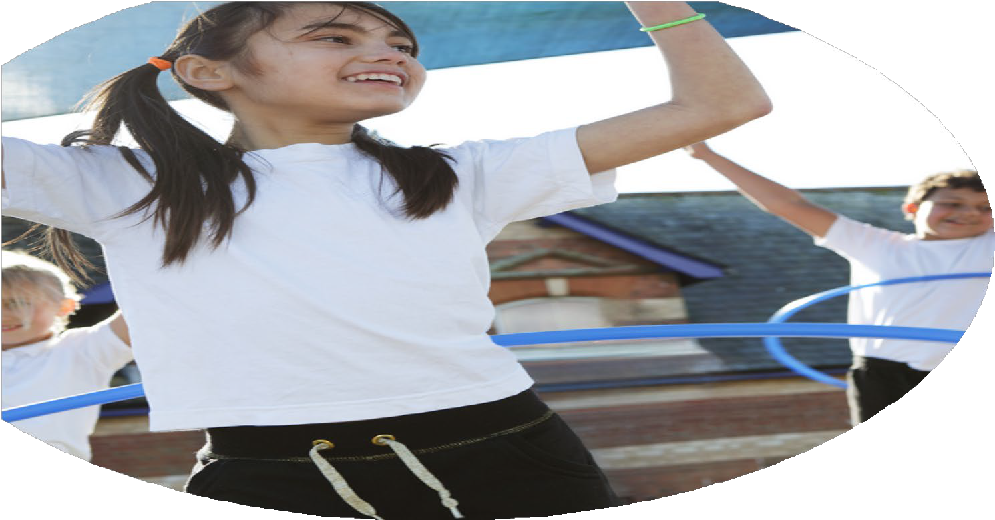

Evaluation Form

**Commissioned by**

**Created by**

Images courtesy of Youth Sport Trust

**PE Funding Evaluation Form**

 It is intended that this template should be used as preparation for the completion of the statutory digital reporting tool being introduced this academic year. You can upload data (including swimming) from this template onto this platform once it becomes accessible.

 Before you decide how you are going to use the funding for this academic year you should reflect and evaluate the impact of your use of the funding in 2023/24.

 All spending of the funding must conform with the terms outlined in the Conditions of Grant document.  The template is a working document that you can amend/update during the year.

 Based on your evaluation of last year’s funding you should decide what you intend to do this academic year, how you will do it, and what impact you expect it to have.

It is important that the funding is used effectively and based on your school’s needs.

 You must use the funding to make additional and sustainable improvements to the PE and sport in your school.  You must develop and add to the PESSPA activities that your school already offers.

*Summative digital reporting from June 2025 will continue to include swimming and water safety information therefore funding can be used to provide top-up lessons where necessary to ensure pupils meet national curriculum swimming requirements.*

**We recommend that you start by reflecting on the impact of current provision and reviewing your previous spend**

|  |  |  |  |
| --- | --- | --- | --- |
| What went well? | How do you know? | What didn’t go well? | How do you know? |
| Increased breadth of study within PE curriculum and extra-curricular activities offered.  Introduce lunchtime sport sessions/activities for pupils.    Introduce new / further develop existing extra-curricular sport sessions/activities for pupils after school  Creation of a school sport council to help collect student voice re: PE and Sport | Addition of Tri Golf, Table tennis and orienteering as new activities to be offered in PE and sports clubs.  New clubs this year include Tag Rugby, Golf and Netball.  We have increased the amount of fixtures vs other local schools, which includes leading local festival-style events for all local primary schools.  Positive feedback from students and sharing ideas of what students would like to see within their lessons. | Some staff upskilled need to do more CPD work with other staff. Staff trained also need further training to extend beyond what we have completed this year.  Increase transport cost has set us back in more fixtures and we have needed to seek income from other school budgets. These costs are continuing to rise.  Capacity of PE lead to lead/manage school sport council and complete next steps following meetings | only 2 members of staff were confident of leading new activities  Prices of coaches going up and of a budget to use for more fixtures. |

|  |  |
| --- | --- |
| What are your plans for 2025/26? | How are you going to action and achieve these plans? |
| Intent | Implementation |
| To continue to increase the breadth of study within PE curriculum and extra-curricular activities offered. Golf will remain a priority this year as we attempt to embed the work started last academic year.  To increase inter school competitions for all students in our school. This will include increased number of ‘house’ / ‘colours’ events within curriculum time.  Increase frequency of intra-school opportunities to allow more students to represent their school more often.  Development of PE curriculum. PE lead to design and implement a new PE programme across all key stages. External organisations / resources may be used. | Using the current 2 staff who are confident to teach golf, those staff well use there time to teach more staff in school to teach Golf and other sports in school. Utilising a local golf project (LittleSticks) to help upskill staff.  Playing in school fixtures and against local schools, this will reduce the cost of coach travel.  Curriculum plans need to include ‘colour competitions’. PE provision (curricular and extra-curricular) also need to be carefully planned to ensure students can access the increased opportunities created.  Use of community clubs and organisations to give expert knowledge in targeted sports and physical activities (eg. increased link with Thetford Cricket Club.  Investigate online PE curriculum platforms as a starting point. Time/capacity for PE lead to redesign/revamp PE curriculum and assessment in PE. |

|  |  |
| --- | --- |
| What impact/intended impact/sustainability are you  expecting? | How will you know? What **evidence** do you have or  expect to have? |
| Increase breadth of study - Increased skills being developed, without focussing on a small number of sports. More students to be confident to engage in sports outside of lessons. Preparation for transition to high school.  Extra-curricular - increased number of students accessing extra provision. Some provisions will be targeted at certain student groups.  Inter-school provision - aims to increase confidence and provide opportunities for students to be competitive / represent a team or group.  PE Curriculum - increased engagement in PE and improved monitoring of progress. | Curriculum plans  Student voice  Extra-curricular participation  Attendance at extra-curricular clubs  Timetable of extra-curricular clubs to be shared with families  Tracking and analysis of house points linked to sports activities and physical activity habits.  Re-written PE curriculum, Basic PE curriculum overview to be published on our school website once developed. |

|  |  |
| --- | --- |
| What **impact/sustainability** have you seen? | What **evidence** do you have? |
| Increased breadth of study within PE curriculum and extra-curricular activities offered:   * New sports added to PE curriculum (Orienteering and Table Tennis). * Equipment purchased for new activities, so no new costs needed to sustain next year. * Feedback from school council has been positive re: new activities being included.   Introduce extra-curricular opportunities for pupils:   * Good attendance at all extra-curricular provision, with regular attendance for a number of weeks (half termly groups commit to the clubs) * Golf - equipment sourced and training completed by PE lead, this project will continue next year, with plans to add Golf to PE curriculum. * Netball - new club as a result from student voice | * PE curriculum overview * School sport council creates a number of ‘voting’ opportunities to include all students in decisions. This data is held by school council reps. * Registers which track attendance at extra-curricular clubs (before school / Lunch / After-school) * Registers for trips/visits/fixtures for sports events - with a target to ensure that all students are given the opportunity to attend at least one opportunity per academic year. * Staff attendance to ‘LittleSticks’ CPD and ongoing support from project lead (Monitoring and feedback forms). |

|  |  |  |
| --- | --- | --- |
| **Swimming data 2024-25** | **Stats:** | **Further context**  **Relative to local challenges** |
| What percentage of your current Year 6 cohort can swim competently, confidently and proficiently over a distance of at least 25 metres? | 30% | *Young people do not have access to swimming in their own time, and families have financial constraints due to the prices in our local leisure centre.* |
| What percentage of your current Year 6 cohort are able to perform safe self-rescue in different water-based situations? | % | *Use this text box to give further context behind the percentage.* |
| If your schools swimming data is below national expectation, you can choose to use the Primary PE and sport premium to provide additional top-up sessions for those pupils that did not meet National Curriculum  requirements after the completion of core lessons. Have you done this? | No | We have not been able to achieve this due to access to the local leisure Centre / times swimming teachers were available. We have plans in place to explore top-up provision next year.  We also face significant barriers re: transport costs to and from school to get to our nearest swimming pool. |
| Have you provided CPD to improve the knowledge and confidence of staff to be able to teach swimming and water safety? | No |  |